# **Abstract:**

Today’s era is marching towards the rapid growth of all sectors including the agricultural sector. Agriculture plays an important role in the life of economy. It is the backbone of our economy system. To meet the future food demands, the farmers have to implement new techniques which will not affect the soil texture but will increase the overall crop production. The aim of this project is to design and develop remote controlled seed sowing machine. The various technique used in Ethiopia for seed sowing and fertilizer placement are manual and ox, these techniques are time consuming and productivity is low also the challenges these farmers face in order achieve it is really troublesome and physically difficult as well. This evident has led to the approach of this project, to develop the seed sowing machine which is to minimize the working cost, time and most importantly the physical pain farmers have to endure in order to plant these crops. In the project we used battery powered wheels and dc motor built-in in these wheels. Another wheel coupled with a dc motor which is used for picking the seeds and placing them in a conical shaped plastic cup. When the seeds are empty it detects the extent of storage seed and indicates the alarm. When any obstacle comes within the in-front of the machine an alarm gives a signal to inform the operator.

# **ACKNOWLEDGEMENT:**

First of all, we would like to thank GOD for helping as reach this goal and achieving this millstone. Next we would like to give our highest gratitude to Electro Mecce for taking us in as their interns and providing a warm working environment for the team and allowing us to learn, experiment and explore all that they could offer and help us build these amazing project and we specifically would like to express our special thanks to all the electrical technicians from Electro Mecce electrical workshop for helping us out and giving us there honest opinions and suggestions while doing our project also our supervisor Mr. Kirubel, Mr. Tilahun and last but not least we would like to thank our families, friends, all the rest Electro Mecce workers and our advisor for being there and supporting us along the way from start to finish.

We wouldn’t be able to say all this without you guys, so thank you all for the love and support!!

**ELECTRO-MECCE ENGINEERING AND AGRO INDUSTRY TRADING PLC**

**Introduction**

* 1. **Brief History**

Electro Mecce is a company that established in 1994 E.C. They have received many awards from the former PM and the current PM which you can see from the wall. They started the business with electrical, industrial and Electromechanical engineering combined in giving services like rewinding, designing and assembling of electrical controlling boards and manufacturing Argo industrial product. With the aim leading technology, innovation and creativity and mission of expansion of engineering sector in our country, it seems to me they are very important company in the capital.

The company is found in Addis Ababa around Global hotel in the street name ’Lancha’, it’s 150m inside the main road. Even if the company have big dreams in becoming a big revolutionary industry in the game, they aren’t equipped with big machineries as someone imagined but they still managed to manufacture the best products that has big impact for the rural area. Their main raw material is sheet of metals with different thickness and according to the design they will be converted to different shapes and with the help of bolts and nuts they are assembled into one to give the desired purpose.

The company has currently produced different types of new inventive products and services that are suitable to the needs of the markets. Feed processing plant in Ethiopia is, very few. On the other hand, Ethiopia has favorable environment for the livestock production. Electro-mecce and Agro industry trading PLC is striving to boost the livestock sectors in its full potential by using appropriate technology for the processing of animal feed in quantity and quality.

Their researches, design and development professional team building technological capacity and manufacturing game changer animal feed machineries to our society to speed up the process of industrialization. And including chopper, compound feed plant, mill, mixer, Pulitzer and many more.

**Vision**

The company big vision in the next couple of years is to be a preferred, inventive, independent, suitable and qualify Engineering solutions provider in Ethiopia. To list the main vison of the company

* Leading the Technology
* Leading innovation and creativity
* Ensures customer satisfaction
* Increase the number of technological products in the country
* Develop and apply reliable and cost-effective technique and technological

**Mission**

To become a preferred, inventive supplier through providing quality engineering solution at competitive price and reliable service that exceeds customer’s expectations of local and international markets.

To contribute to the country’s economic growth and increase shareholder’s equity by supporting the industrialization processes, creating job opportunity and committing tour corporate social responsibility

* The major focus of our activity in establishing successful long-term relationship with our customers and suppliers
* Expansion of engineering sector in our country
* Creates linkage and growth in the industry and agricultural sector
* Supports the government in technology research and result
* Advise and assist effective solutions to our customers

**Values**

* Leadership, transformational learning
* Team work partnership and strategic alliance, relevance
* Electro Mecce engineering service today is the leading electro mechanical manufacturer and trusted feed machinery producer brand in Ethiopia.

**Member of**

* Addis Ababa chamber of commerce and secretarial Association
* Animal Feed industry Association
* Ethiopian poultry producers association

**Brief Objective**

* To provide and serve to the needy with a special Electro Mechanically and industrial electric engineering capability amassed over along years of experience at exceptional environment
* To introduce technologically reliable cost-effective solutions to a wide variety of market needs.
* As institute to produce skilled manpower with a qualitative on the job training.
* Constant upgrade and modernize technical capability to provide and speedy service.

Electro Mecce is a big company that manufacture seventy different type of animal feed machinery in Ethiopia for the past 19 years. And also, we started exporting we started exporting feed machineries for African market. This giant organization is working with Ministry of agriculture, University, CNFA, Federal unions and TVTS college.

**Electro-Mecce Products**

They have manufactured different types of animal feed processing machinery and integrated compound animal feed machineries

* Maize Sheller
* Seed cleaner machine
* Tomato squeezer, seed separator, seed dryer
* Compound animal feed machinery/ mill and mixer with transporter auger
* Different type of hammer mill
* Different type of vertical mixer
* Corn thrasher
* Different type of horizontal mixer
* Crop residue processing machines
* Plastic shredder machine
* Ground nut decorator
* Coffee roaster and mill
* Poultry feed machinery

**Electro-Mecce Services**

This company service including a wide variety of activities, including product design industrial process design, system engineering and maintenance and operation, the following are the few from the most

* Transportation and supply
* Rewinding of electric motors generators coil and submersible pumps
* Repair services for all electrically operated machines
* Installation of electrical panel
* Training of electrical panel
* Training of the operator
* One-year warranty with preventive maintenance
* Different types of free engineering consultancy service
* After sales service for our products

**Electro-Mecce Organizational Structure**

The company organized by more energetically, dynamic, young, motivated and efficient senior management team, currently led by the business owner and general manager Mr. Ephreme Hailu Tamrat.

**Management**

**Team**

**Planning/designing**

**Project operation**

**Admin/finance**

**Project management team**

**Commercial team**

**Management Team**

The business is driven by our 4 working directors. They are involved in the business development, procurement, project management and administration of the company. The management team proactively gathers feedbacks, identifies changes in a business environment, reviews work process and communicate key learning points and company policies to all staffs at regular meetings.

**The employees of the company**

The employees of the company are very crucial in the delivery of their services and solution to our clients in order to ensure that everyone is equipped with the right skill, knowledge and attitude, a comprehensive training program is put in the place to constantly upgrade our people in technical and management skills. We believe firmly in providing the right training, accredited certification and practical knowledge of our people, in order for them to execute their duties and responsibilities confidently. The company’s big aim is to stay relevant in the ever-changing market place and clients’ equipment.

**Main Advantages of Their Products**

* Reduce human labor
* Contribute to our country GDP
* Availability of spare parts
* Short delivery time
* Reliable machines
* Availability of assistance

# **Overall internship experience**

* As we all live in Addis Ababa the first criteria to choose a company that we are going to apply for internship should be in Addis Ababa. So that we tried to submit our application letter as much as we can in companies that are in Addis Ababa from these electro mecce engineering service was one of them and also it was the only one that accepts our internship program.
* In electro mecce engineering service there are sections like management, design, mechanical workshop, electrical workshop and painting workshop. Among these sections we were working on the design section to improve different machineries that are manufactured by this company. We were also working on the mechanical workshop section where machineries manufactured and assembled and in electrical workshop too where controlling boards produced and different machines like motor, grinder and others maintained.
* In the mechanical workshop first the workers understand the design that have been given to them, collect the necessary working materials from the storage or personnel then manufacture the machinery part by part and then assemble all the parts and finally test the performance of the machinery. If there is a defect on it, they try to detect the defect and get rid of that and test again until it has reached the desired performance. And in electrical section if there are machines that has failed, they will be maintained like for example rewinding of a motor, maintaining a grinder and the like. It is also the section where different controlling boards and different wirings done.
* The works that we have been experiencing were grinding different kinds of metal, welding, drilling and manufacturing different parts of machinery in the mechanical section and in electrical section we have been experiencing how to rewind a motor, how to draw the drawing of a motor before rewinding, how to do control boards wiring and we also experienced how to design a machine using SW.
* The procedures that we have been using were the same as the company employs while we were performing our activities.
* As we didn’t spend a lot of time in workshops in our school it wasn’t that easy to adapt the working area or environment and perform the work tasks easily. But through time and from our interest of the work we did well. And we were doing our works as an assistant to the workers of the company.
* The challenges that we have faced during our internship period were COVID-19, financial problems and transportation problems. COVID-19 is a global pandemic that have ruined many sectors in our country and the educational sector was one of the victims of this global pandemic. Because of this our internship program was post ponded to about seven months and we have been at home through all those times. The second problem is the financial problems that are raised because of the very elongated period of our internship. As we were at home for a long time the budget that we received from our university was almost wasted and then when we return to our company there were many financial problems. As we know here in Addis Ababa there is a large-scale traffic crowed specially in the morning and it was a struggle to be punctual.
* As COVID-19 was a challenge to our world we took the measures to be safe that are pointed by health care organizations and we tried to solve our financial problems by asking family to provide us money. The last problem that we faced was the transportation problem and we tried to solve this by waking up early in the morning and go to our company before many people get out of their home for work and the road become crowded, so that we can get to our company on time.

# **Benefits of Internship and Improving Skills**

**Introduction**

As Electromechanical student or any university student, the internship program is the most exciting time of our campus. Mainly it is because you get to practice what we learned in the class for the last three years in well-known companies throughout the country according to our location and preferences. Internships offer students a hands-on opportunity to work in their desired filed. An internship is an excellent way to find out how well you do in the real career world.

**Improving practical skills**

Internships are useful for developing soft skills and interpersonal skills, such as professionalism, cultural sensitivity, time management and integrity, that are not generally part of the formal tertiary education curriculum. Especially as engineer student knowing or learning only about theories is almost worthless if we can’t have the chance to practice what we have learned in theory.

Having an internship gives us experience in the career field we want to pursue. Not only does this give us an edge over other candidates when applying for jobs, it also prepares them for what to expect in their field and increases confidence in our future work.

Our first time not only we were new to practical work, we weren’t also aware of many equipment names and particular use. The first few weeks we were with the employees almost the whole time to be familiar with the company’s routine and work activity. Once we fully understood the work and the products, they let us to practice with the equipment’s before engaging with the main products. We actually got better through time on handling the apparatus. The practical skills that we picked up are like grinding, welding, drilling, wiring, installation and rewinding of electric motor are the main examples from many.

Beside practical skills, having an internship benefits us in the working environment and it also builds our professional network. Internships provide a great environment to meet professionals in the career field we want to pursue, as well as other interns who have similar interests.

**Upgrading Theoretical knowledge**

For many of us university can be quite theoretical and an internship is our first opportunity to apply their knowledge to the real world. In campus we have taken multiple courses on different topics but unfortunate enough we weren’t able to practice them.

We have taken courses like Electrical machine, which we learned in details about various electrical motors like Induction, synchronous, DC and AC motors. In this company we had the chance to disassemble the motors to its finest parts and see every component and how the principle actually works.

The main things that we learned in this particular lesson was, how to rewind an electrical motor, what are the steps to the assembling. There were also moments that many of the electrical course that we learned from class come to a definite use. We have taken courses on workshops and maintenance, there were many equipment that were mentioned in the course but we had hard times remembering those because we were new to their names but now not only, we know their names we also understand how to fully handle them.

**Communication Skills**

It is always difficult at first to communicate with someone specially in work place where you work as intern student, it was difficult to ask some question that we fully didn’t understand till there was some acquaintance between us and the whole company’s employee. We used our internship program as a way to speak with employees and learn from their experiences. We tried to get involved with the team and company events such as lunches, drinks and social activities.

Communication is very basic thing not only in this particular case but also in life, because if someone is very good at this it’s easier to introduce yourself to people in office, ask them about their mistake and success, how to overcome challenges. The development of our communication skills needs to be an on-going part of our professional learning and development. since our communication skills developed throughout the month the things, we learnt from them also increased. The other thing we learnt which is very basic, don’t wait for feedback to be given by your manager. Actively seed feedback from your peers to ensure you are constantly learning and improving your communication skills.

**Team Playing skills**

In Electro-mecce company there are seven intern students which is all from Hawassa university. The best thing about working I groups we can learn from one another and is like filling the hole someone left unintentionally. Team work is always important on making any work or project faster and effective. There are many skills that we need to require to have the best team in order to have effective.

Teamwork happens when people cooperate and use their individual skills to achieve common goals. Top teamwork skills include:

1. **Communication**

The ability to get your point across and truly understand what other people want to tell you is the core stone effective teamwork.

1. **Conflict resolution**

Conflict is part and parcel of any team effort. What matters most is how adept you are at dealing with issues as they arise. Remember, it’s crucial not to let any conflicts escalate that’s why the best team players are also great mediators.

1. **Rapport-building and listening**

You can only build rapport if you’re listening to other people’s voices. Mind you it’s equally important to pay heed to their enthusiasm and the lack of it. Rapport and listening skills go hand in hand, one can’t exist without the other.

1. **Decision Making**

Making decisions may seem like a pretty straightforward thing to do. And that’s case when everyone agrees on the course of action. But everything changes when opinions start to differ and you need to make an unpopular decision.

1. **Problem solving**

The very idea behind organizing a team is to solve a problem. That’s why problem-solving skills are fundamental for each and every team member. The ability to look at an issue from multiple angles and utilize youth time management skills on the basis of individual team member’s skills drive the entire team’s performance and success.

**6. Organizational and planning skills**

To solve any problem effectively and efficiently you must be able to devise a master plan that every team member understands, follows, and knows where it leads to. Once the plan is agreed upon, all team members will be able to organize their tasks, establish deadlines, and orchestrate their efforts.

1. **Persuasion and influencing skills**

Being persuasive isn’t a character trait. It’s a skill you can learn. In the context

of teamwork, this applies mostly to team leaders who must inspire everyone to

contribute to achieving team goals and objectives. A good start to build

such [leadership skills](https://zety.com/blog/leadership-skills) is to hone-in on your [presentation skills](https://zety.com/blog/presentation-skills).

1. **Reliability**

Teams form because they can achieve more than each team member could on their own. That’s obvious, isn’t it? What people tend to forget, though, is that when working together as a team you depend on the others as much as they depend on you. Show your reliability by sticking to deadlines, delivering your tasks, and overcommunicating any obstacles along the way.

Combining the above crucial points, we have always found a way to overcome any obstacle that faced us. We had given multiple tasks, were asked to come up with ideas and also to find solutions for problems, and we did it together adding all our best ideas and combining them to one.

**Work Ethics and Leadership**

One of the most important things in work life and every social life is first impression and the behavior that we show in work place. The other thing very important to consider is work ethics, Work ethic is a belief that hard work and diligence have a moral benefit and an inherent ability, virtue or value to strengthen character and individual abilities. ... Social ingrainment of this value is considered to enhance character through hard work that is respective to an individual's field of work.

We were able to learn about work ethics from the employees many of them had years of experiences and the ability to perform the tasks that they assigned too. Work ethics start from the clothes that you were to the way you treat your colleagues to being punctual on time.

Accepting responsibility and accountability for decisions and actions taken while at the internship site; Ensuring that all interactions with guests, patients, clients, members, customers, the public and fellow employees are conducted with dignity and respect towards every person.

Leadership is very important of any organization and every team. But nobody can be a leader out nowhere to be a leader you need to have a certain quality. Here is a list of must-have leadership skills that may prove valuable to anyone applying for work or looking to advance in a career:

* Decisiveness. ...
* Integrity. ...
* Relationship building (or team building) ...
* Problem-solving. ...
* Dependability. ...
* Ability to teach and mentor.

Internships really are a win-win situation. They can help you decide if a particular career or area is or isn’t for you, and narrow down the (often long) list of careers that you are interested in to find one that you will be happy in. If you don’t enjoy your internship experience then, at the very least, it will have helped you to determine that a particular area isn’t for you. Don’t give up, you can always try another internship in a different organization, role or a completely different field and see if you like it any better. Every experience helps you to define and redirect your career path.

**Entrepreneurship Skills**

The best thing about internship isn’t only we get to practice what we learned in class but also, we will get to see the highlights of future of life for four months. Entrepreneurship internships are a fantastic starting point if we have plans to start own company in the future.

The start-up experience will benefit the young professional involved and the host company by bringing together real business development experience and the brightest students who bring new ideas, differing skill sets and high amounts of enthusiasm. A true entrepreneur will put their career or financial security on the line in the name of an idea with the potential of making a huge return.

So, after knowing all this we might have found our future based on the mistakes that the employees made, the vibrant business that we witnessed and the many opportunities that company has been missing. Electro mecce engineering service is the most profitable company that we come across or even heard of and it is amazing how they only doing a very small amount of percentage than they actually can.

As an electromechanical engineer who is well aware of the work environment and how money flows around the company, it is really to come up with new idea and have new product. But being entrepreneur is not only having idea because having only idea is completely worthless unless you don’t have the team and sources to make that idea come to life.

**List of figures:**

**Figure No. Description Page No.**

**Figure 1** Ethiopian farmers sowing seed 3

**Figure 2**  Sowing seed by hand 4

**Figure 3** Arduino UNO micro-controller 13

**Figure 4** Arduino IDE Interface 17

**Figure 5** Bluetooth module 20

**Figure 6**  DC motors 22

**Figure 7** Motor driver shield 23

**Figure 8** Jumper cables 25

**Figure 9** 9V batteries 26

**Figure 10**  Block diagram 28

**Figure 11** Solid Works mechanical model 30

# Chapter one: **Introduction**

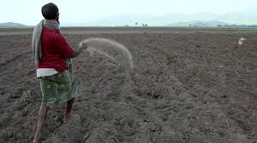 Cropping is important and tedious activity for any farmer, and for large scale this activity is so lengthy also it needs more workers. Thus, agriculture machines were  
developed to simplify the human efforts. In manual method of seed planting, we get results such as low seed placement, less spacing efficiencies and serious back ache for the farmer. This also limited the size of field that can be planted. Hence for achieving best performance from a seed planter, the above limits should be optimized. Thus, we need to make proper design of the agriculture machine  
and also selection of the components is also required on the machine to suit the needs of crops.

*Fig 1. Ethiopian farmers sowing seed*

The agriculture is the backbone of Ethiopia. And for sustainable growth of Ethiopia development of agriculture plays vital role. The Ethiopia has huge population and day by day it is growing thus demand of food is also increasing. In

agriculture we have seen various machines. Also, there traditional methods are there. Since long ago in Ethiopia, traditional method is still being used. Ethiopia has huge man power. This manual planting is popular in villages of Ethiopia. But for large scale this method is very troublesome. The farmer has to spend most of his time planting. But the time available is little to provide for all the people. It requires more man power to complete the task within stipulated time which is costlier. Also, more wastage happens during manual planting. Hence there is need of developing such a machine. In the current generation most of the countries do not have sufficient skilled man power specially in agricultural sector and it affects the growth of developing countries. The main requirement of automation is to reduce man power in our country at the same time increase productivity

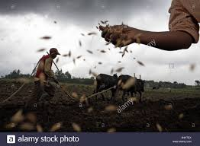

*Fig 2. Seed sowing by hand*

Automation saves a lot of tedious manual work and speeds up the production

processes. So, it is a time to automate the sector to overcome this problem. In

Ethiopia there are 70% of the population depending on agriculture. Seed has been

an important agricultural commodity since the first crop plant was domesticated by

pre-historic man. In this model seed sowing process is automated to reduce the

human effort and increase the yield. The plantation of seeds is automatically done

by using DC motor. The distance between the two seeds are controlled and varied

using Microcontroller. It is also possible to cultivate different kinds of seeds with

different distance. When the system reaches the end of the field, we can change the

direction with the help of remote switches.

## 1.1 Background of study:

In current world, every process is getting automated and people are getting used to adopt smart techniques to get their work done. It can be seen that with flow of time, how seed sowing techniques and equipment’s have kept on progressing. Proper seed sowing is very important part of agricultural process and for the same purpose hand operated seed sowing machine have been designed and developed. Despite agriculture being one of the most important fields for determining the growth of a country, it is lagging in terms of smart working. One of the biggest ironies is agriculture being the main occupation in many countries still it lags in using the smart techniques in this field. If technology is introduced in farming techniques there are chances that ever-growing populating in the coming future might be fed adequately. To suffice such a large amount, agricultural yield must also be increased rapidly. Due to poor seed quality & inefficient farming practices, and lack of cold storage and harvest spoilage, nearly 30% of the farmer’s produce is wasted. Not in just theory practically we can see how automation helps in increasing output of farming, in US, where automation techniques in agricultural farming has already been implemented the cereal yield is nearly 8281 Kg/Hectare which is

three times more than in Ethiopia whose cereal yield is just 2538Kg/Hectare

approximately as of a research from 2017. These figures clearly show that there is great need of introducing automation techniques in every small and big agricultural farming because, if appropriate measures are not taken at the right time, even though currently many countries have adequate stock of food to suffice its population, a time may come when same will not be able to feed its entire population. The current shortage of goods during the COVID – 19 pandemics can be a good example. As a result of it the development of such countries will severely be affected and they may not be able to become a developed nation. Automation in seed sowing will help in proper use of available resources. To implement automation in the process of sowing seeds in agricultural farming, the machines that are already being used can be improved in design or new machines or attachments can be developed to do the necessary operations. But these machines or attachments should be cost effective and be affordable to the farmers. Hence a less expensive, distinct machine or attachment has to be designed and developed so that it can be used for different crops and in different seasons. It will help to increase output with same amount of input by sowing the seed at proper distance so that each seed gives best output as it is known that sowing of seed with proper gap is an important parameter in farming.

## **1.2 Problem of statement**:

Growing the crop means ploughing the field and

sowing the seeds into it. Three steps are mainly taken to sow the seed; Spreading

the seeds over the soil, separate germination of seeds, and sowing the seeds into

the soil. The two latter processes take more time and labor to complete the work.

It being the area of concern needs to be looked upon, Currently the farmers in

developing countries are facing challenges while trying to keep the production

going and as an engineer we need to find a solution to help reduce the hard work

they have to face every day. Hence, an idea to implement the automation in the

process of seed sowing raised.

## **1.3 Project Objectives**:

For an agriculture sector to be successful one needs to

add the booming technologies as input and take care of the processes and at the

same time knowing the behavior of the technology and the major role that it is

going to play in the sector of one’s interest. In the present growing aspect, the need

to utilize the available technologies has become necessity in order to gain the best

result. The general objective is to increase the productivity of our production in

food industry for the population by reducing the time of plantation and also

introducing newer technologies to farmers in order to adapt and coupe with the

productive invention which will increase the over all result and help the country

grow also these technologies help out fellow hard-working men and women in

creating easier application of sowing seeds which minimizes the physical

challenges they face every day, as well as to increasing their efficiency.

* **Sowing seeds with proper distance and depth**

Due to this machine, we are able to plant seeds with proper distance

between them so amount required to sowing of seed per hector are fix.

This also helps to increase the germination of seed, because seed to seed

space is proper so plant get space to grow up.

* **Reduce Time**

The most important objective for this invention is to reduce the time of

sowing seeds with fertilization. In the conventional method the sowing by

means of hands (manually) which take too much time to complete the

sowing in the whole farm. Reduce in time result in increasing the

efficiency.

* **Reduce Work done**

Due to this invention the total work done by the farmer for sowing is

decreases, because the farmer has not to carry the heavy bag of seeds and

fertilizer and throughout the sowing process and the work of sowing by

means of hands also gone reduce. The reason for these findings is due to the

law of diminishing returns. The law of diminishing returns states that there

will be a decreasing return for each additional increment of fertilizer applied.

In attempting to obtain maximum yields, the last increment of fertilizer

applied will increase the yield by a smaller amount than the previous

increment. Therefore, a given amount of fertilizer on an under-fertilized part

of the field will result in a much larger yield increase than that same amount

of fertilizer applied to an over-fertilized portion of the field.

## 1.4 Project scopes:

In our project we tried to consider all the things listed below;

project objective:

* Design and create a machine that helps speed up a crop planting process and

reduce the manual labor required to do so.

* Reduce the time taken by manual seed sowing process and increase productivity.
* Make a product that can do the required task for the customers while being in affordable package.

Deliverables:

* A finished automated seed sowing machine which is controlled using a mobile phone.
* A machine that notifies the operator when there isn't enough seed to be planted.
* A machine that regulates the seed proportionality/ seed spacing by controlling its speed during planting.

Millstones:

* Gathered all the equipment needed to do the project ....... "date"
* Finished building a prototype .......
* Performed a test run ........

Technical requirements:

* The machine must plant seed without the need of any manual labor.
* The machine must be durable and reliable.
* Needs to be easy to operate.

Limits and exclusions:

Mechanical factors, which affect seed germination and are:

* Weather/ climate during the planting process.
* Uniformity of depth of placement of seed.
* Uniformity of distribution of seed along rows.
* Transverse displacement of seed from the row.
* Prevention of loose soil getting under the seed.
* Uniformity of soil cover over the seed.
* Mixing of fertilizer with seed during placement in the furrow.

To achieve the best performance from a seed planter, the above factors are to

be optimized by proper design and selection of the components required on the

machine to suit the needs of the crops.

# Chapter Two: **Literature Review**

In order to come up with the idea of the project we did a research on how the world is sowing seed these days and what innovations have people came up with to tackle this problem and we came across many inventions related to our project and by doing so we tried to combine the pros with our ideas at the same time tried to understand what the limitations were, and we tried to address the cons in order to design a much suitable machine which is easy to use at the same time that gets the job done. So all the cited sites, journals, article… are as follows;

**Mahesh R. Pundkar** [1] stated that the seed sowing machine is a key component

of agriculture field. high precision pneumatic planters have been developed for

many verities of crops, for a wide range of seed sizes, resulting to uniform seeds

distribution along the travel path, in seed spacing**.**

**M.A. Asoodar [2]** another agricultural researcher determined the effects of

different seeding technique and machines and also different rates of oilseed rape

application on seeding emergence plant establishment and final grain yield.

**P.P. Shelke** [3] concludes that bullock drawn planters are becoming necessity for

sowing as the skilled workers for sowing are almost diminishing. Planting distance

and plant population are crucial factors in maximizing the yields of crops**.**

**Singh (1971) [4**] revealed that by using a seed drill for wheat crop there was an

increase in yield by 13.025 percent when compared with the conventional method,

it also revealed that by using a seed drill for wheat crop**,** a saving of 69.96 per cent

in man-hours and 55.17 percent in hillock hours was achieved when compared,

with the conventional method.

**Umed Ali Soomro** at al. [5] in Pakistan has evaluated three sowing methods and

seed rate in a four replicated RCBD method and concluded that drilling method of

sowing at seed rate 125kg/ha is optimal for yield and quality of wheat grains,

because the said sowing method and seed rate distribute seed uniformly and

desired depth which provide appropriate depth for seed germination and crop

establishment**.** The main goal of M.A. Asoodar [2] another agricultural researcher

determined the effects of different seeding technique and machines and also

different rates of oilseed rape application on seeding emergence plant

establishment and final grain yield.

# Chapter Three: **Methodology**

* During the build process we used many parts from building the structure to assembling the parts and some of the

technology we used for our project are:

## 3.1 Technology used

### 3.1.1 **Arduino Uno:**

Arduino Uno is the heart of system which is connected with all the sensors and other hardware assembly required to achieve the desire work. The features of Arduino Uno that it is a small, complete, and breadboard friendly board based on  
the ATmega328.The ATmega368 has 32 KB of flash memory for storing code in which 2 KB is used for the bootloader. The ATmega368 has 2 KB of SRAM and 1 KB of EEPROM. It is low cost and easily available controller. All the software  
programming is written in Arduino Integrated Development Environment (IDE).

Arduino IDE is open-source software which makes it easy to write code and upload it to the Arduino board. It runs on the Windows, Mac OS X, and  
Linux. Interrupts are used in programming to make system more effective and respond to changes accordingly.

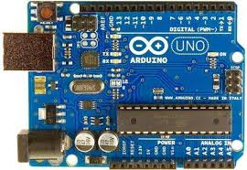

*Fig 3. Arduino UNO micro controller*

**Technical specifications**

* Microcontroller: Microchip [ATmega328P](https://en.wikipedia.org/wiki/ATmega328P)
* Operating Voltage: 5 Volts
* Input Voltage: 7 to 20 Volts
* Digital I/O Pins: 14 (of which 6 can provide PWM output)
* UART: 1
* I2C: 1
* SPPI: 1
* Analog Input Pins: 6
* DC Current per I/O Pin: 20 mA
* DC Current for 3.3V Pin: 50 mA
* Flash Memory: 32 KB of which 0.5 KB used by bootloader
* [SRAM](https://en.wikipedia.org/wiki/Static_random-access_memory): 2 KB
* EEPROM: 1 KB
* Clock Speed: 16 MHz
* Length: 68.6 mm
* Width: 53.4 mm
* Weight: 25 g

**General pin function**

* **LED**: There is a built-in LED driven by digital pin 13. When the pin Is high value, the LED is on, when the pin is low, it is off.
* **VIN**: The input voltage to the Arduino/Genuino board when it is using an external power source (as opposed to 5 volts from the USB connection or other regulated power source). You can supply voltage through this pin, or, if supplying voltage via the power jack, access it through this pin.
* **5V**: This pin outputs a regulated 5V from the regulator on the board. The board can be supplied with power either from the DC power jack (7 - 20V), the USB connector (5V), or the VIN pin of the board (7-20V). Supplying voltage via the 5V or 3.3V pins bypasses the regulator, and can damage the board.
* **3V3**: A 3.3-volt supply generated by the on-board regulator. Maximum current draw is 50 mA.
* **GND**: Ground pins.
* **IOREF**: This pin on the Arduino/Genuino board provides the voltage reference with which the microcontroller operates. A properly configured shield can read the IOREF pin voltage and select the appropriate power source, or enable voltage translators on the outputs to work with the 5V or 3.3V.
* **Reset**: Typically used to add a reset button to shields that block the one on the board.

**Special pin function**

Each of the 14 digital pins and 6 analog pins on the Uno can be used as an input or output, under software control (using pinMode (), digitalWrite (), and digitalRead () functions). They operate at 5 volts. Each pin can provide or receive 20 mA as the recommended operating condition and has an internal pull-up resistor (disconnected by default) of 20-50K ohm. A maximum of 40mA must not be exceeded on any I/O pin to avoid permanent damage to the microcontroller. The Uno has 6 analog inputs, labeled A0 through A5; each provides 10 bits of resolution (i.e. 1024 different values). By default, they measure from ground to 5 volts, though it is possible to change the upper end of the range using the AREF pin and the analogReference () function.

In addition, some pins have specialized functions:

* **Serial** / UART: pins 0 (RX) and 1 (TX). Used to receive (RX) and transmit (TX) TTL serial data. These pins are connected to the corresponding pins of the ATmega8U2 USB-to-TTL serial chip.
* **External interrupts**: pins 2 and 3. These pins can be configured to trigger an interrupt on a low value, a rising or falling edge, or a change in value.
* **PWM** (pulse-width modulation): pins 3, 5, 6, 9, 10, and 11. Can provide 8-bit PWM output with the analogWrite () function.
* **SPI** (Serial Peripheral Interface): pins 10 (SS), 11 (MOSI), 12 (MISO), and 13 (SCK). These pins support SPI communication using the SPI library.
* **TWI** (two-wire interface) / [I²C](https://en.wikipedia.org/wiki/I%C2%B2C): pin SDA (A4) and pin SCL (A5). Support TWI communication using the Wire library.
* **AREF** (analog reference): Reference voltage for the analog inputs.

### 3.1.2 **Arduino IDE:**

The Arduino Integrated Development Environment (IDE) IDE stands for integrated development environment. It is a computer program that encompasses the tools required by programmers to develop software. Common elements found in an IDE include a source code editor, compiler, builder and debugger. Programmers use IDEs over simple text editors because of the convenience they provide when writing code.

The source code for the IDE is released under the [GNU General Public License](https://en.wikipedia.org/wiki/GNU_General_Public_License), version 2. The Arduino IDE supports the languages C and C++ using special rules of code structuring. The Arduino IDE supplies software library from the wiring project, which provides many common input and output procedures. User-written code only requires two basic functions, for starting the sketch and the main program loop, that are compiled and linked with a program stub *main()* into an executable cyclic exclusive program with the [GNU toolchain](https://en.wikipedia.org/wiki/GNU_toolchain), also included with the IDE distribution. The Arduino IDE employs the program *avrdude* to convert the executable code into a text file in hexadecimal encoding that is loaded

into the Arduino board by a loader program in the board's firmware. By default, avrdude is used as the uploading tool to flash the user code onto official Arduino boards.

Examples of IDEs include Visual Studio Express, Eclipse and Net Beans. Every IDE has its unique features and benefits, along with their own drawbacks. IDEs have specific language support, with some being limited to only one programming language. They also vary according to the different kinds of software development, such as mobile, web and desktop.

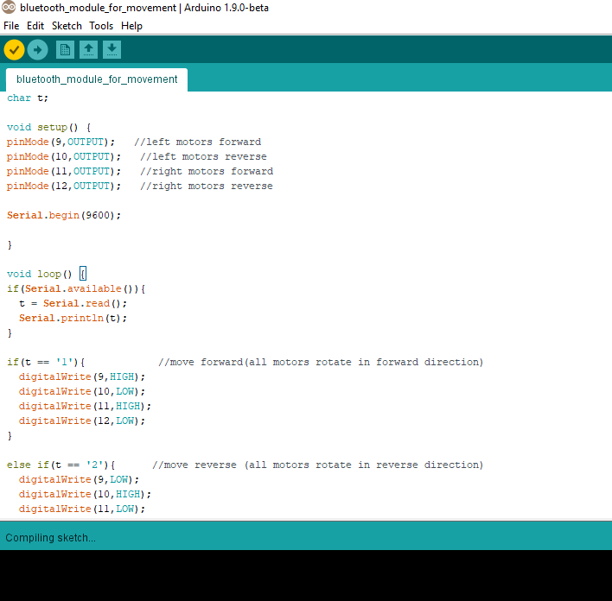

*Fig 4. Arduino IDE interface*

### 3.1.3 **Bluetooth Module for Android Base Movement:**

Wheels are embedded with Gear Motors; they are unable to move until the motor are electrically energized. So, to manually control the movement of robot, Bluetooth module is used to communicate to the Android Mobile. the android application which is used to send signals to the robot. The controller receives the signals and generates commands accordingly.

First thing you need to do is identify your module. It can be either HC05 or HC06. Both the modules are same in functionality except the pinout. Also, HC05 can act as both master and slave whereas HC06 functions only as slave. It's hard to differentiate between the two only by seeing. One probable way would be checking the back of the breakout board. If it has "JY-MCU" written on the back, it's probably a HC06. Mine has "ZS-040" written and it is a HC05. And the HC06 module I tested had a Bluetooth sign behind with three pcb foot prints (refer to figure2). To confirm the device identity, you can power up the module, search for new device on your pc or mobile, and look for HC05 or HC06 on found device list.

HC-05 Bluetooth Module is an easy-to-use Bluetooth SPP (Serial Port Protocol) module, designed for transparent wireless serial connection setup. Its communication is via serial communication which makes an easy way to interface with controller or PC. HC-05 Bluetooth module provides switching mode between master and slave mode which means it able to use neither receiving nor transmitting data.

**Specification:**

• Model: HC-05  
• Input Voltage: DC 5V  
• Communication Method: Serial Communication  
• Master and slave mode can be switched

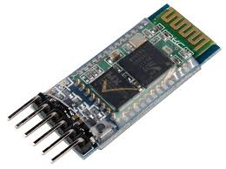

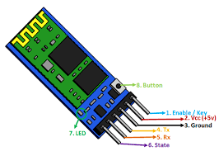

*Fig 5. Bluetooth module*

### 3.1.4 **DC motors:**

**DC motors** are one of the easiest components to test out – simply hook up a battery within the correct voltage range for the motor, and away it goes! This standard “130” DC motor is designed to work with between 4.5V and 9V DC and will start spinning at voltages a slow as 2.0V. The motor has two pre-soldered leads, DC motors normally have just two leads, one positive and one negative. If you connect these two leads directly to a battery, the motor will rotate. If you switch the leads, the motor will rotate in the opposite direction.

To control the direction of the spin of DC motor, without changing the way that the leads are connected, you can use a circuit called an H-Bridge. An H bridge is an electronic circuit that can drive the motor in both directions. H-bridges are used in many different applications, one of the most common being to control motors in robots. It is called an H-bridge because it uses four transistors connected in such a way that the schematic diagram looks like an "H."

**Specification:**

* operating Temperature: -10°C ~ +60°C
* Rated Load: 10 g*cm
* No-load Speed: 9100 ±1800 rpm
* Loaded Speed: 4500 ±1500 rpm
* Starting Voltage: 2.0V
* Body Size: 27.5mm x 20mm x 15mm
* Rated Voltage: 6.0VDC
* No-load Current: 70 mA max
* Loaded Current: 250 mA max
* Starting Torque: 20 g*cm
* Stall Current: 500mA max
* Shaft Size: 8mm x 2mm diameter

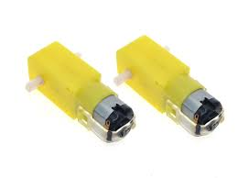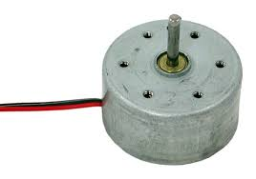

*Fig 6. DC motors*

|  |  |  |
| --- | --- | --- |
| **N1** | **IN2** | **MOTOR** |
| 0 | 0 | BRAKE |
| 1 | 0 | FORWARD |
| 0 | 1 | BACKWARD |
| 1 | 1 | BRAKE |

### 3.1.5 **Motor Driver shield:**

For a safe and sufficient motor control design, discrete components are needed. Some of them must be dedicated to the motor application. Due to the possibility of using the Shield with loads which can draw a current of up to 55 A the connectors Vbat, GND, OUT1 and OUT2 are designed as solid 4mm through whole connectors. This provides the possibility to connect plugs which are capable of such high currents. Nevertheless, the thermal performance of the Shield itself limits the possible current which should be applied to the Motor Control Shield to 30 A. To reach the best performance in terms of parasitic inductance and EMC a GND plane, with maximal size was designed.

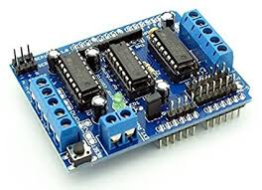

*Fig 7. Motor driver shield*

**Specification:**

* Brushed DC Motor Control up to 250 W continuous load
* 8 – 18 V nominal input voltage (max. 6 – 40 V)
* Average motor current 30 A restricted due to the limited power dissipation

of the PCB (BTN8982TA current limitation @ 55 A min.)

• Drives either one brushed bi-directional DC motor or two uni-directional

DC motors.  
• Capable of high frequency PWM, e.g. 30 kHz  
• Adjustable slew rates for optimized EMI by changing external resistor  
• Driver circuit with logic level inputs  
• Status flag diagnosis with current sense capability  
• Protection e.g. against overtemperature and overcurrent  
• Reverse polarity protection with IPD90P04P4L

### 3.1.6 **Arduino Jumper Cable:**

10X 30cm 3P Female (F-F) Arduino Jumper Cable Cables Wire Wires Sensor Shields. **Usage**: For Arduino board, Arduino sensor and shields board connection. Jumper to board to board too. Length: 30cm.

**Type**: Female to Female (F-F). (depends on Countries too). Pitch: 2.54mm. Connector: 3 pin connector Condition：

Breadboard jumper wire 65 pcs pack (Male to Male header). Including 4 different length:200mm,165mm,125mm and  
80mm.A must have component for breadboard.

**SPECIFICATION**

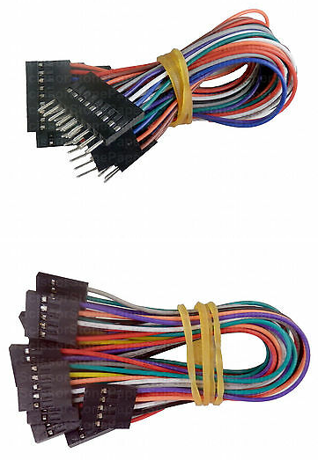• 240mm (9.4in) x5  
• 200mm (7.9in) x5  
• 150mm (5.9in) x8  
• 110mm (4.3in) x49

*Fig 8. Jumper cables*

### 3.1.7 **Nine -volt battery:**

9-volt batteries power our smoke alarms, household items and toys.  
They can be found in most homes. But these batteries can be a fire hazard  
if not stored safely or disposed of with care. The nine-volt battery format is commonly available in primary carbon-zinc and alkaline chemistry, in primary lithium iron disulfide, and in rechargeable form in nickel-cadmium, nickel-metal hydride and lithium-ion The size, regardless of chemistry, is commonly designated **PP3**—a designation originally reserved solely for carbon-zinc, or in some countries, *E* or *E-block*.

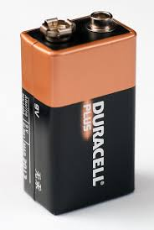

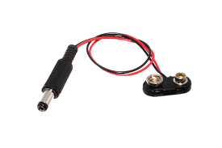

*Fig 9. 9V battery and a connector*

**The problem**

* 9-volt batteries can be dangerous. The positive and negative posts are close  
  together. If a metal object touches the two posts of a 9-volt battery, it can cause a short circuit. This can make enough heat to start a fire.
* It is unsafe to store 9-volt batteries in a drawer near paper clips, coins, pens, or other batteries. Do not store common household items such as steel wool, aluminum foil, and keys near 9-volt batteries. If these items touch the two posts, there is a greater risk of a fire starting.

**Storing 9-volt batteries**

* Keep batteries in original packaging until you are ready to use them. If loose, keep the posts covered with masking, duct, or electrical tape. Prevent the posts from coming in contact with metal objects.
* Keep them someplace safe where they won’t be  
  tossed around.
* Store batteries standing up.
* 9-volt batteries should not be stored loose in a drawer.  
  Do not store them in containers with other batteries.

## 3.2 SYSTEM ARCHITECTURE

Architecture of system gives overall idea of the project and how system components are connected to each other and perform their role of work in this project. Arduino Uno is main technology used in this project. A 9V power supply is provided and passed through regulator so that it can be converted to 3.3v and provided to Arduino Uno. The input given as embedded ‘C’ Code to Arduino device which is interface with L293D motor driver IC and the output from this is given to motor. The motors are connected to wheels which moves the robot and seed plantation process is done.

## 3.3 Block Diagram:

POWER SUPPLY/ 9V batteries

DC Motor

3

**Micro-Controller**/

ARDUINO UNO

Motor Driver

shield

Bluetooth module

DC Motor

1

DC Motor

2

*Fig 10. Block diagram*

## 3.4 Solid works Model of our project:

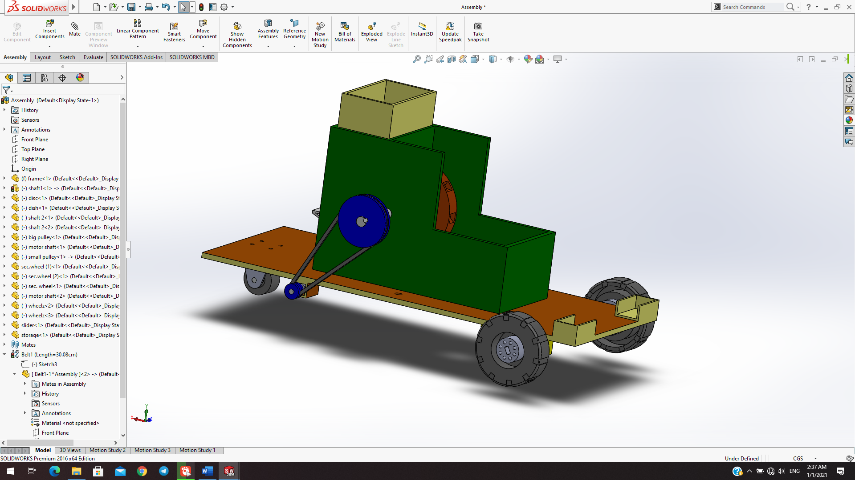

*Fig 11. Solid Works mechanical model*

For our project using solid works was essential as it helped us better visualize what parts we needed to make and use in-order to make them as light as possible while still being effective also to simulate using the built-in simulation system to further understand the mechanics how the parts will operate once they were assembled. Therefore, solid work played an important role for the design process and more.

# Chapter Four: **Expected Result**

By putting the seed and fertilizer in rows at desired depth and seed to seed spacing, cover the seeds with soil and provide proper compaction over the seed. The recommended seed to seed spacing and depth of seed placement is varying from crop to crop and for different agro-climate conditions to achieve optimum yields.

**CONCLUSION**

This robot is designed using DC components and the whole system is battery operated. So solar panels might be used to charge the batteries at the locations where people face electricity problem and where there is no availability of electricity. As a future enhancement, the robot is also designed in such a way that it will not only be used for the seed sowing process of maize crops but will also be used for some other crops like Bean, Cotton and Grain. The robot can also be used for fertilizing and spraying pesticides to the crop fields. As the robot sow the seeds after specified distance so weed detection and recognition also become easier in such a way that every plant that grows between specified distance is  
unwanted.

# **REFERENCES**

1. S.M Bashi, N. Mariun and A.rafa (2007). ‗Power Transformer protection using

microcontroller based relay‘, Journal of applied science,.

2. Swetha S.1 and harsha G.H.2, “Solar Operated Automatic  
Seed Sowing Machine”, Cloud Publications International Journal of Advanced Agricultural Sciences and Technology 2015, Volume 4, Issue 1, pp. 6771,February 2015.

3. Kyada, A. R Patel,“Design and Development of Manually Operated Seed Planter Machine”, 5th International & 26th All India Manufacturing Technology, Design and Research Conference, Assam, India, December 12th–14th, 2014.

4. http://www.iraj.in/journal/journal_file/journal_pdf/1-120-142815439551-53.pdf

5. I. B. Gartseev, L. F. Lee, and V. N. Krovi, “A low-cost realtime mobile robot platform (ArEduBot) to support projectbased learning in robotics & mechatronics,” in Proc. 2nd International Conference on Robotics in Education, INNOC Austrian Society for Innovative Computer Sciences, 2011.

6. B. Astrand and A. Baerdveldt, A vision based row following system for agricultural field machinery,vol. 15, no. 2, pp.251269, 2005

7. Jincui Kang, J. G. (2012). Application of Ontology Technology in Agricultural Information.2nd International Conference on Computer and Information Application (ICCIA 2012) (pp. 1183-1186). Atlantis Press, Paris, France